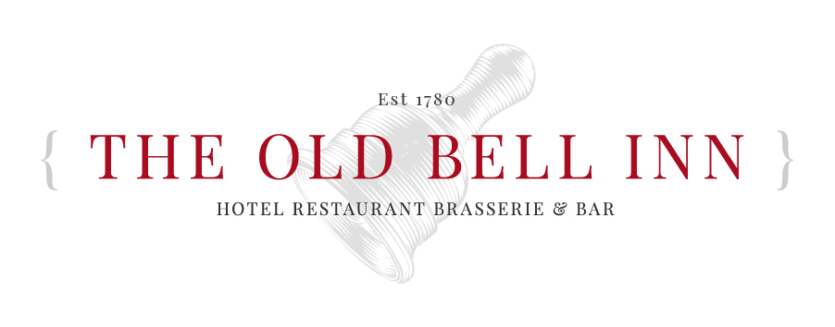
  - Party Menu 1 - £25 Per Person

  - SOUP OF THE DAY Freshly baked bread
  - CHICKEN LIVER PARFAIT Fruit chutney, toasted ciabatta, mixed leaf
  - ATLANTIC PRAWN COCKTAIL Tomato salsa, gin Marie rose, lemon
  - CREAMY GARLIC MUSHROOMS Toasted ciabatta

  - WHITBY WHOLETAIL BREADED SCAMPI Hand cut chips, garden peas, homemade chunky tartar sauce
  - STEAK & TIMOTHY TAYLORS ALE PIE Seasonal vegetable, hand cut chips, gravy
  - PORK LOIN CHOP Crushed new potatoes, cider cream sauce, spring greens
  - ROASTED CHICKEN LEG Garlic crushed new potatoes, fine beans, white wine cream sauce
  - MEDITERRANEAN VEGETABLE TAGLIATELLE (V) Roasted tomato sauce

  - SELECTION OF ICE CREAMS Brandy snap biscuit, shortbread crumb
  - THE OLD BELL INN CLASSIC STICKY TOFFEE PUDDING Served with Lydgate cream, vanilla bean ice cream or custard
  - FRUIT CRUMBLE Oatmeal crumb, served with Lydgate cream, vanilla bean ice cream or custard
  - FRESH FRUIT SALAD & SORBET

