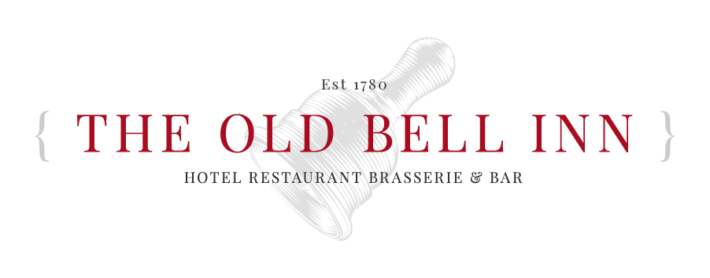
  - Party Menu 2 - £35 Per Person

  - SOUP OF THE DAY Freshly baked bread
  - PAN FRIED GARLIC KING PRAWNS Tomato salsa, toasted ciabatta
  - SMOKED HAM & CHEESE CROQUETTES Dressed mixed leaves, tomato chutney
  - HOI SIN JACKFRUIT SPRING ROLLS (VE) Pickled cucumber, sweet chilli dipping sauce
CHICKEN LIVER PARFAIT Fruit chutney, toasted ciabatta, mixed leaves

  - PAN ROASTED CHICKEN BREAST
  - Bubble & squeak croquettes, chanteney carrots, fine beans, white wine & tarragon sauce
  - PAN SEARED SEABASS SUPREME Chorizo & roasted tomato tagliatelle, king prawns, spinach
  - BEEF BOURGUIGNON White grain mustard mash, charred baby leeks
  - ROASTED PORK BELLY Pancetta, peas & broad beans, celeriac fondant, black pudding bon bon, cider sauce
  - SWEET POTATO & LENTIL COTTAGE PIE (VE) Seasonal vegetables, vegan gravy

  - THE OLD BELL INN CLASSIC STICKY TOFFEE PUDDING Served with Lydgate cream, vanilla bean ice cream or custard
  - STRAWBERRY CHEESECAKE ETON MESS Black pepper meringue, strawberries, basil glass, strawberry sorbet
  - POACHED PEAR
  - Toasted granola, baileys crème analgise
  - COCONUT MILK PANA COTTA (VE) Vegan meringue, pineapple & Malibu chutney, passionfruit puree
  - LOCAL CHEESE BOARD Grapes, celery, homemade date & walnut loaf, red onion marmalade, sourdough biscuits

