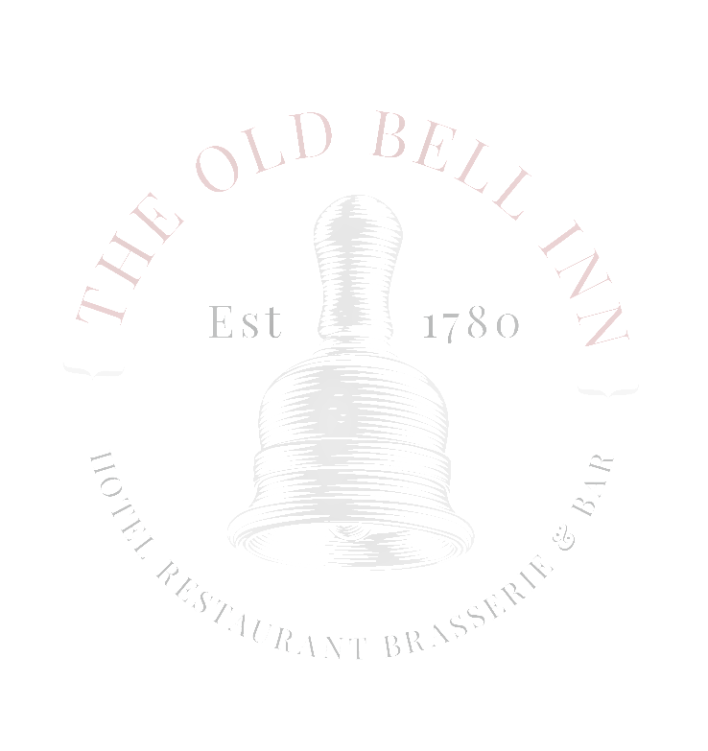
  - SUNDAY MENU 2 courses £15.95 3 courses £19.95
  - STARTERS
  - SOUP OF THE DAY
  - Local baked bread
  - HOMEMADE CHICKEN LIVER PARFAIT Toasted ciabatta, fruit chutney, dressed mixed leaf
  - ATLANTIC PRAWN COCKTAIL
  - Marie rose, tomato salsa, lemon

  - WHITE WINE CREAMED GARLIC MUSHROOMS
  - Toasted ciabatta, watercress

  - MAINS
  - SLOW ROAST TOPSIDE OF BEEF Dripping roast potatoes, creamed potato, seasonal vegetables, Yorkshire pudding and gravy
  - SLOW ROAST PORK WITH CRACKLING
  - Dripping roast potatoes, creamed potato, seasonal vegetables, Yorkshire pudding and gravy

  - SLOW ROAST LEG OF LAMB (£1 supplement) Dripping roast potatoes, creamed potato, seasonal vegetables, Yorkshire pudding and gravy

  - MEDITERRANEAN VEGETABLE TAGLIATELLE (V)
  - Roasted tomato sauce

  - PORK & CRACKED BLACK PEPPER SAUSAGES
  - Wholegrain mustard creamed potato, garden peas, onion gravy

  - DESSERTS
  - THE OLD BELL INN STICKY TOFFEE PUDDING AND BUTTERSCOTCH SAUCE
  - Served with Lydgate cream, vanilla bean ice cream or custard

  - STRAWBERRY CHEESECAKE ETON MESS
  - Black pepper meringue, strawberries, basil glass, strawberry sorbet
  - LOCAL CHEESE PLATE
  - Served with grapes, celery and sourdough biscuits

  - SELECTION OF 3 ICE CREAMS, BRANDY SNAP BASKET

