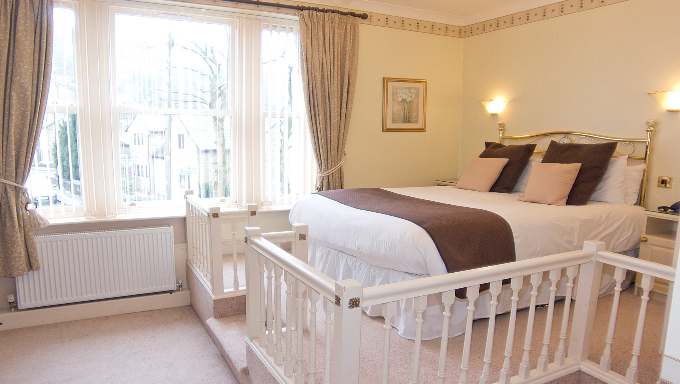

**WEEKEND SPECIAL**

**50% OFF**

**YOUR DINNER RESERVATION**

**THROUGHOUT FEBRUARY &MARCH**

**WITH ANY DOUBLE ROOM BOOKED**

**FRIDAY, SATURDAY OR SUNDAY**

**TERMS & CONDITIONS: OFFER AVAILABLE THROUGHOUT FEBRUARY & MARCH (EXCLUDING 14TH & 15TH FEBRUARY) 50% OFF FOOD ONLY. THIS OFFER DOES NOT APPLY ON DRINKS. DIRECT BOOKINGS ONLY. DINNER RESERVATIONS FROM 6PM. BOOKINGS ESSENTIAL. QUOTE WEEKEND SPECIAL ON BOOKING.**