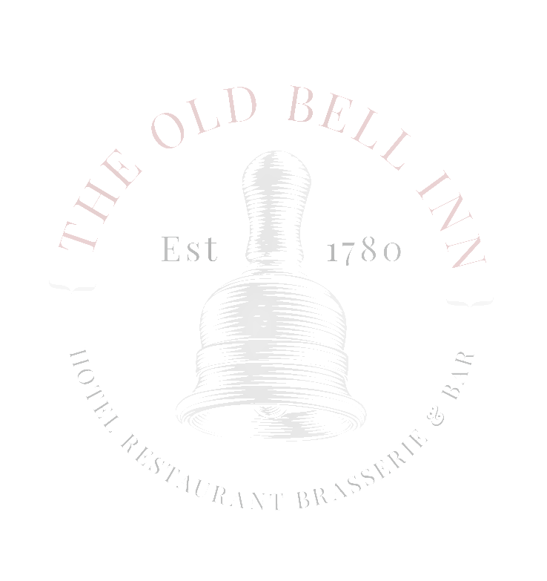
APPETISERS / NIBBLES

GARLIC BREAD CIABATTA - £3.50 WITH CHEESE - £3.95, OR SUNBLUSHED TOMATO & CHEESE £4.50 (V)

NOCERELLA OLIVES & BREAD WITH EXTRA VIRGIN OLIVE OIL & AGED BALSAMIC VINEGAR £4.95 (V)

WARM PITTA BREADS AND SWEET CHILLI MAYONNAISE, BLACK OLIVE TAPENADE & HOMEMADE HUMMUS - £4.95 (V)

CHICKEN WINGS – CHOOSE FROM BBQ OR SALT AND PEPPER - £4.95

BEER BATTERED CALAMARI – LEMON MAYONNAISE - £4.95

STARTERS

SOUP OF THE DAY (V)
LOCAL BAKED BREAD
£5.95

CREAMY GARLIC MUSHROOMS (VEGAN OPTION AVAILABLE) (V)
TOASTED CIABATTA, WATERCRESS
£6.50

ATLANTIC PRAWN COCKTAIL
TOMATO SALSA, GIN MARIE ROSE, GEM LETTUCE, LEMON
£7.50

HOI SIN JACKFRIUT SPRING ROLLS (VE)
PICKLED CUCUMBER, SWEET CHILLI DIPPING SAUCE
£7.50

HOMEMADE CHICKEN LIVER PARFAIT
FRUIT CHUTNEY, TOASTED CIABATTA, DRESSED LEAVES
£7.50

PAN FRIED KING PRAWNS WITH CHILLI & GARLIC
SERVED WITH A CHORIZO AND TOMATO RISOTTO, BASIL OIL
£9.95

MAINS

WHITBY WHOLETAIL BREADED SCAMPI
HAND CUT CHIPS, GARDEN PEAS, HOMEMADE CHUNKY TARTAR SAUCE
£12.95

STEAMED BEEF RAG PUDDING
TIMOTHY TAYLORS BEER BRAISED MINCE STEAK AND DICED BRITISH BEEF, HAND CUT CHIPS, THYME ROASTED CHANTENAY CARROTS, GRAVY
£13.50

FISH & SEAFOOD PIE
TOPPED WITH VINTAGE CHEDDAR MASHED POTATO, MIXED BABY LEAF SALAD
£13.95

WILD MUSHROOM RAVIOLI (V)
SAUTEED MUSHROOMS, LEEKS, SPINACH, BLUE CHEESE CREAM SAUCE
£12.95

STEAK & TIMOTHY TAYLORS ALE PIE
SEASONAL VEGETABLES, HAND CUT CHIPS, GRAVY
£13.95

BEER BATTERED HADDOCK
HAND CUT CHIPS, MUSHY PEAS & HOMEMADE CHUNKY TARTAR SAUCE
£13.95

FOUR CHEESE & ONION PIE (V)
HAND CUT CHIPS, BAKED BEANS, BABY MIXED LEAF, TOMATO CHUTNEY
£13.95

SWEET POTATO & LENTIL COTTAGE PIE (V) (VE)
SEASONAL VEGETABLES, VEGAN GRAVY
£12.95

PAN FRIED SEABASS
KING PRAWN WHITE WINE, CHILLI, CREAM TAGLIATELLE
£17.95

ROASTED DUCK BREAST
SWEET POTATO CROQUETTE, BRAISED RED CABBAGE, CARROT AND CHILLI PUREE, PAK CHOI, ANISE JUS
£18.95

STEAKS
10OZ RIBEYE £24.95
10OZ RUMP £19.95
8OZ FILLET £26.95

35 DAY AGED STEAKS SERVED WITH PORTOBELLO MUSHROOM, SLOW ROAST TOMATO, HAND CUT CHIPS, CRISPY ONIONS, WATERCRESS

PLATTERS TO SHARE (FOR TWO) ALL £21.95
PLOUGHMANS
SMOKED HAM HOCK, VINTAGE CHEDDAR, MATURE STILTON, SCOTCH EGG, PORK PIE, PICCALILLI, MIXED SALAD, CRUSTY BREAD

MEZZE
SERRANO HAM, HUMMUS, OLIVES, SUNBLUSHED TOMATOES, FETA, MIXED SALAD, CHORIZO, PITTA BREAD, PICCALINO PEPPERS

MEDITERRANAEAN
FETA, OLIVES, SWEET POTATO, HUMMUS, BOILED EGG, TZATZIKI, AVOCADO, SUN BLUSHED TOMATO, ROASTED PEPPERS, PITTA BREAD

SALAD BOWLS
MEDITERRANAEAN
FETA, OLIVES, HUMMUS, ROAST VEG, SWEET POTATO, BOILED EGG, TOMATO, CUCUMBER, RED ONION
£11.95

FREE RANGE CHICKEN CAESAR
BACON, AVOCADO, BABY GEM, BOILED EGG, CHERRY TOMATO GARLIC CROUTONS
£12.50

SMOKED DUCK
MIXED LETTUCE, CUCUMBER, CHERRY TOMATOES, RED ONION,BOILED EGG, SWEET POTATO,RASPBERRY WALNUT DRESSING
£12.95

SALT AND PEPPER CHICKEN BREAST
SWEET CHILLI NOODLE SALAD, DRESSED LEAVES, CRUNCHY VEGETABLES
£12.50

BURGERS
CLASSIC
BEEF PATTE, PORTABELLO MUSHROOM
£12.95

CAJUN CHICKEN
FREE RANGE CHICKEN BREAST, RUBBED WITH BLEND OF CAJUN SPICES, SWEET CHILLI MAYONNAISE
£12.95

CHEESE BURGER
BEEF PATTIE, VINTAGE CHEESE
£12.95

BEYOND BEEF BURGER (VE)
RED ONION MARMALADE
£12.50

ALL BURGERS SERVED WITH LETTUCE, TOMATO, GHERKIN, FRIES AND ONION RINGS

SIDES

SKINNY FRIES/CAJUN FRIES
£3.50

TRUFFLE & PARMESAN FRIES
£3.95

HAND CUT CHIPS WITH SEA SALT AND CRACKED BLACK PEPPER
£3.95

BEER BATTERED ONION RINGS
£3.50

SWEET POTATO FRIES, GARLIC AIOLI
£3.95

ROCKET, SUNBLUSHED TOMATO & PARMESAN SALAD
£3.95

SANDWICHES

STEAK SANDWICH
SMOOTHED OR BLACK & BLUE- RUMP STEAK, ONIONS, MUSHROOMS, TOPPED WITH EITHER VINTAGE CHEDDAR OR CAJUN AND BLUE CHEESE
£9.95

TIMOTHY TAYLORS BEER BATTERED HADDOCK FINGERS
MUSHY PEAS, TARTAR SAUCE
£8.95

CHICKEN, BACON, AVOCADO
CUCUMBER, RED ONION TOMATO, BABY GEM & AIOLI
£8.95

HOI SIN JACK FRUIT
SAUTEED PEPPERS, ONIONS, MUSHROOMS (V) (VE)
£7.95

GRILLED GOATS CHEESE
PEPPERS, RED ONION MARMALADE, WATERCRESS
£8.95

ALL SERVED ON EITHER WHITE OR BROWN CIAPANINI WITH MIXED SALAD LEAF & HOMEMADE COLESLAW

ADD FRIES, CHUNKY CHIPS OR SWEET POTATO FRIES FOR £1.95

