SENIOR CITIZENS SPECAIL
….AND THOSE WITH A SMALLER APPETITE
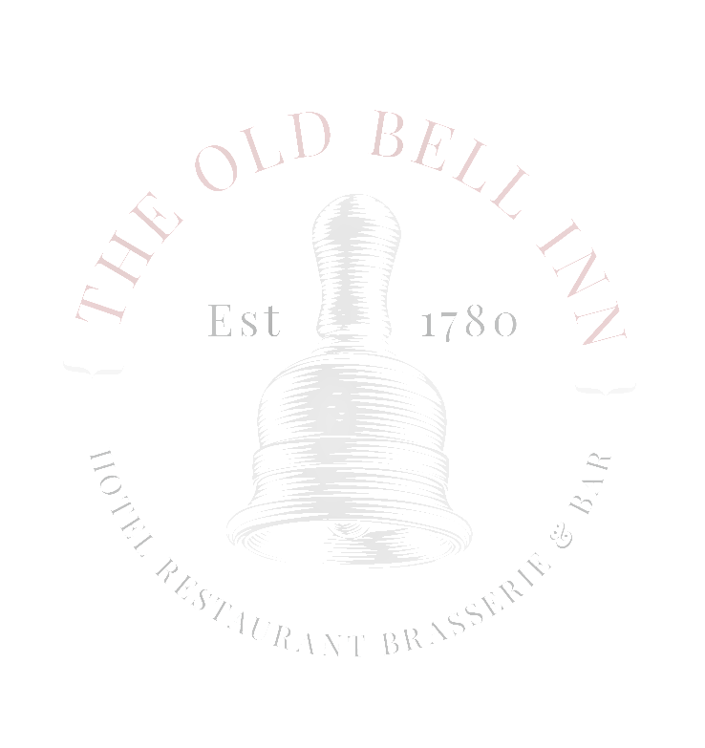
SERVED MONDAY TO SATURDAY 12 – 6PM
STARTERS
SOUP OF THE DAY (V)
LOCAL BAKED BREAD

PRAWN COCKTAIL
GIN MARIE ROSE, TOMATO SALSA, BABY GEM (£1 SUPPLEMENT)

CREAMY GARLIC MUSHROOMS (VEGAN OPTION AVAILABVLE) (V)
TOASTED CIABATTA

HOMEMADE CHICKEN LIVER PARFAIT
FRUIT CHUTNEY, TOASTED CIABATTA, DRESSED LEAVES

MAINS
STEAMED BEEF RAG PUDDING
HAND CUT CHIPS, GRAVY, MUSHY PEAS

BEER BATTERED HADDOCK
HAND CUT CHIPS, TARTAR SAUCE, MUSHY PEAS (£1.50 SUPPLEMENT)

WHITBY WHOLETAIL BREADED SCAMPI
HAND CUT CHIPS, GARDEN PEAS, HOMEMADE CHUNKY TARTAR SAUCE

OLD BELL INN CLASSIC FISH PIE
MIXED SALAD

PORK LOIN CHOP
CRUSHED NEW POTATOES, CIDER CREAM SAUCE, MIXED GREENS (£1 SUPPLEMENT)

WILD MUSHROOM RAVIOLI
SAUTEED MUSHROOMS, LEEKS, SPINACH, BLUE CHEESE CREAM SAUCE (V)

SWEET POTATO & LENTIL COTTAGE PIE (V) (VE)
SEASONAL VEGETABLES, VEGAN GRAVY

DESSERTS
BAILEYS AND VANILLA CHEESECAKE
CHOCOLATE AND ORANGE SAUCE, STRAWBERRIES

OLD BELL INN CLASSIC STICKY TOFFEE PUDDING
TOFFEE SAUCE, SERVED WITH CUSTARD OR ICE CREAM

SELECTION OF ICE CREAMS
SERVED WITH BRANDY SNAP BASKET AND SHORTBREAD CRUMB

FRUIT CRUMBLE
SHORTBREAD CRUMB, SERVED WITH CUSTARD OR LYDGATE CREAM

2 COURSES FOR £9.95 OR 3 COURSES £12.95

