CHILDRENS MENU
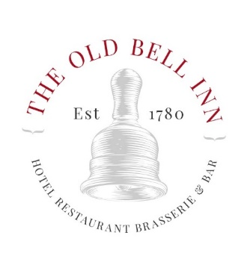
STARTERS
OLD BELL INN SOUP OF THE DAY WITH FRESHLY BAKED BREAD
TOASTED CIABATTA AND HUMMUS
GARLIC BREAD/ GARLIC BREAD AND CHEESE/ GARLIC BREAD CHEESE AND TOMATO
MAINS
BEEF BURGER, FRENCH FRIES, BAKED BEANS
HADDOCK GOUJONS, FRENCH FRIES, BEANS OR PEAS
CHICKEN GOUJONS, FRENCH FRIES, BEANS OR PEAS
SWEET POTATO AND LENTIL COTTAGE PIE, GARDEN PEAS, VEGAN GRAVY (V) (VE)
DESSERTS
TWO SCOOPS OF HOMEMADE ICE CREAM
STICKY TOFFEE PUDDING SERVED WITH CUSTARD OR ICE CREAM
CHOCOLATE FILLED PROFITEROLES, SALTED CARAMEL SAUCE, CHANTILLY CREAM

2 COURSES £10.95 3 COURSES £13.95

