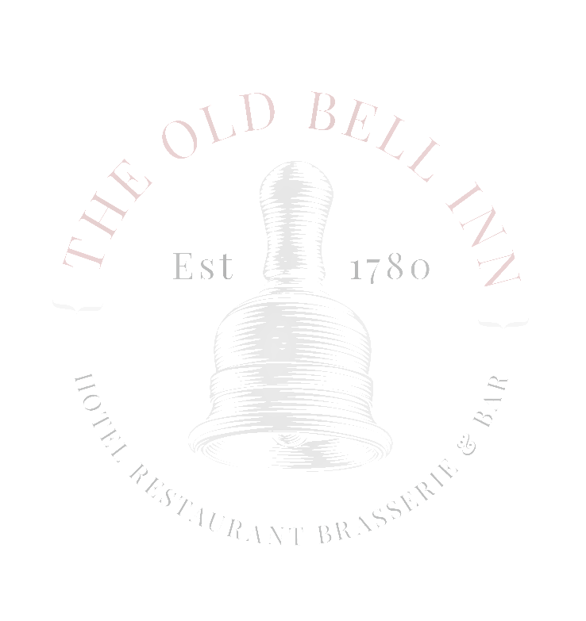
APPETISERS / NIBBLES

GARLIC BREAD CIABATTA - £4.50 WITH CHEESE - £4.95, OR SUNBLUSHED TOMATO & CHEESE £5.50 (V)

NOCERELLA OLIVES & BREAD WITH EXTRA VIRGIN OLIVE OIL & AGED BALSAMIC VINEGAR £6.95 (V)

STARTERS

SOUP OF THE DAY (V)
LOCAL BAKED BREAD
£6.50

CREAMY GARLIC MUSHROOMS (VEGAN OPTION AVAILABLE) (V)
TOASTED CIABATTA, WATERCRESS
£6.95

ATLANTIC PRAWN COCKTAIL
TOMATO SALSA, GIN MARIE ROSE, GEM LETTUCE, LEMON
£7.95

HOMEMADE CHICKEN LIVER PARFAIT
FRUIT CHUTNEY, TOASTED CIABATTA, DRESSED LEAVES
£7.95

GRATINATED KING PRAWN AND QUEEN SCALLOPS, TOPPED WITH GARLIC BUTTER, PARMESAN AND LEMON BUTTER
SERVED WITH DRESSED MIXED LEAF
£10.95

SWEET POTATO AND JACKFRUIT CROQUETTE (VE)
SERVED WITH BBQ SAUCE AND DRESSED MIXED SALAD
£7.50

MAINS

PAN FRIED LAMBS LIVER AND BACON
CREAMED POTATO, BUTTERED GREENS, WITH ONION GRAVY
£13.95

WHITBY WHOLETAIL BREADED SCAMPI
HAND CUT CHIPS, GARDEN PEAS, HOMEMADE CHUNKY TARTAR SAUCE
£12.95

STEAMED BEEF RAG PUDDING
TIMOTHY TAYLORS BEER BRAISED MINCE STEAK AND DICED BRITISH BEEF, HAND CUT CHIPS, CRUSHED GARLIC PEAS, GRAVY
£13.95

FISH & SEAFOOD PIE
TOPPED WITH VINTAGE CHEDDAR MASHED POTATO, MIXED BABY LEAF SALAD / SEASONAL VEGETABLES
£14.95

WILD MUSHROOM RAVIOLI (V)
SAUTEED MUSHROOMS, LEEKS, SPINACH, BLUE CHEESE CREAM SAUCE
£13.95

STEAK & TIMOTHY TAYLORS ALE PIE
SEASONAL VEGETABLES, HAND CUT CHIPS, GRAVY
£14.95

BEER BATTERED HADDOCK
HAND CUT CHIPS, MUSHY PEAS & HOMEMADE CHUNKY TARTAR SAUCE
£14.95

FOUR CHEESE & ONION PIE (V)
HAND CUT CHIPS, BAKED BEANS, BABY MIXED LEAF, TOMATO CHUTNEY
£14.95

NO BULL COTTAGE PIE TOPPED WITH SWEET POTATO MASH (V) (VE)
SEASONAL VEGETABLES, VEGAN GRAVY
£13.95

PAN FRIED SEABASS
KING PRAWN WHITE WINE, CHILLI, CREAM TAGLIATELLE
£18.95

PAN ROASTED LAMB RUMP
WHOLEGRAIN MUSTARD CREAMED POTATOES, TENDERSTEM BROCOLLI WITH A REDCURRANT AND ROSEMARY JUS
£19.95

STEAKS
10OZ RIBEYE £25.95
8OZ FILLET £26.95

35 DAY AGED STEAKS SERVED WITH PORTOBELLO MUSHROOM, SLOW ROAST TOMATO, HAND CUT CHIPS, CRISPY ONIONS, WATERCRESS

SIDES

SKINNY FRIES/CAJUN FRIES
£3.95

TRUFFLE & PARMESAN FRIES
£4.95

HAND CUT CHIPS WITH SEA SALT AND CRACKED BLACK PEPPER
£3.95

SWEET POTATO FRIES, GARLIC MAYONNAISE
£4.95

BABY MIXED LEAF, SUNBLUSHED TOMATO & PARMESAN SALAD
£4.50

DIRTY FRIES

TOPPED WITH….

• CHORIZO, PANCETTA, PARMESAN, SIRACHA MAYONNAISE

• SALT AND PEPPER SEASONING, PEPPERS, ONIONS, CHILLIES

• BBQ JACKFRUIT, ONIONS PEPPERS

• HOISIN SHREDDED DUCK, SPRING ONION, CHILLIES

£6.95

BURGERS

GROUND BRITISH BEEF BURGER
MATURE CHEDDAR, BACON, RED ONION MARMALADE, SKIN ON FRIES, BEER BATTERED ONION RINGS
£12.95

CAJUN CHICKEN NACHO BURGER
TOMATO CHUTNEY, AVOCADO MAYONNAISE, SKIN ON FRIES, BEER BATTERED ONION RINGS
£12.95

BEYOND BEEF BURGER (V)(VE)
VEGAN CHEESE, BBQ SAUCE, SKIN ON FRIES, ONION RINGS
£12.50

SALAD BOWLS
MEDITERRANEAN SALAD (V)(VE)
VEGAN CHEESE, OLIVES, HUMMUS, ROAST VEG, SWEET POTATO, TOMATO, CUCUMBER, RED ONION
£12.95

FREE RANGE CHICKEN CAESAR SALAD
BACON, AVOCADO, BABY GEM, CHERRY TOMATO GARLIC CROUTONS
£12.95

