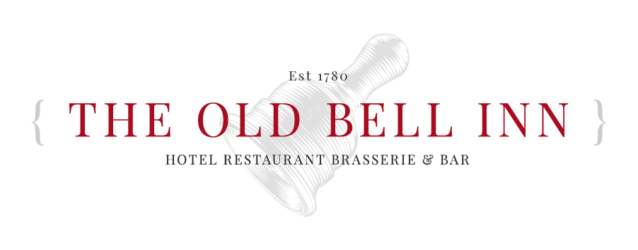

  - SIDE ORDERS & EXTRA’S
  - STUFFING & CHIPOLATAS £1.25

CAULIFLOWER & LEEK CHEESE
FOR 1 £2.95
FOR 2 £4.95

YORKSHIRE PUDDING £0.75
EXTRA SLICE OF MEAT
BEEF £2.00
PORK £2.00
LAMB £2.00
  - SUNDAY MENU
2 courses £19.95
3 courses £23.95

STARTERS
SOUP OF THE DAY (VE)
Local baked bread
HOMEMADE CHICKEN LIVER PARFAIT Toasted ciabatta, fruit chutney, dressed mixed leaf
ATLANTIC PRAWN COCKTAIL
Marie rose, tomato salsa, lemon
CREAMY GARLIC MUSHROOMS
Toasted ciabatta, watercress

MAINS
SLOW ROAST TOPSIDE OF BEEF Dripping roast potatoes, creamed potato, seasonal vegetables, Yorkshire pudding and gravy
SLOW ROAST PORK AND CRACKLING
Dripping roast potatoes, creamed potato, seasonal vegetables, Yorkshire pudding and gravy, crackling
SLOW ROASTED LEG OF LAMB
Dripping roast potatoes, creamed potato, seasonal vegetables, Yorkshire pudding and gravy
£2.00 supplement
NUT ROAST (VE)
Roast Potatoes, creamed potato mash, seasonal vegetables and gravy

DESSERTS
OLD BELL INN CLASSIC STICKY TOFFEE PUDDING
Toffee sauce, served with custard, cream or ice cream
SELECTION OF ICE CREAMS
Served with brandy snap basket, shortbread crumb and popping candy
CHOCOLATE LAVA CAKE
Melt in the middle pudding, with honeycomb ice cream, honeycomb crumb and white chocolate shavings
WINTER BERRY SPONGE CAKE (VE.V)
Served with a fruit compote, vegan vanilla ice cream and sugared rosemary
CHOCOLATE AND CHERRY CHEESECAKE
With a baileys sauce, cherry compote and a coffee chantilly cream

